**120A3051**

**Shreya Idate**

**Batch: E3**

**Experiment No: 12**

**AIM**: Demonstration of JIRA

**THEORY**:

Jira Software is part of a family of products designed to help teams of all types manage work. Originally, Jira was designed as a bug and issue tracker. But today, Jira has evolved into a powerful work management tool for all kinds of use cases, from requirements and test case management to agile software development.

Jira for agile teams

For teams who practice agile methodologies, Jira Software provides scrum and kanban boards out-of-the-box. Boards are task management hubs, where tasks are mapped to customizable workflows. Boards provide transparency across teamwork and visibility into the status of every work item. Time tracking capabilities and real-time performance reports (burn-up/down charts, sprint reports, velocity charts) enable teams to closely monitor their productivity over time.

Jira for project management teams

Jira Software can be configured to fit any type of project. Teams can start with a project template or create their own custom workflow. Jira issues, also known as tasks, track each piece of work that needs to pass through the workflow steps to completion. Customizable permissions enable admins to determine who can see and perform which actions. With all project information in place, reports can be generated to track progress, productivity, and ensure nothing slips.

Jira for software development teams

Jira Software provides planning and roadmap tools so teams can manage stakeholders, budgets, and feature requirements from day one. Jira integrates with a variety of CI/CD tools to facilitate transparency throughout the software development life cycle. When it’s ready to deploy, live production code status information is surfaced in the Jira issue. Integrated feature flagging tools allow teams to roll out new features gradually and safely.

The DevOps template is designed for high-performing teams to save time and reduce errors by managing work from a variety of tools in one centralized place.

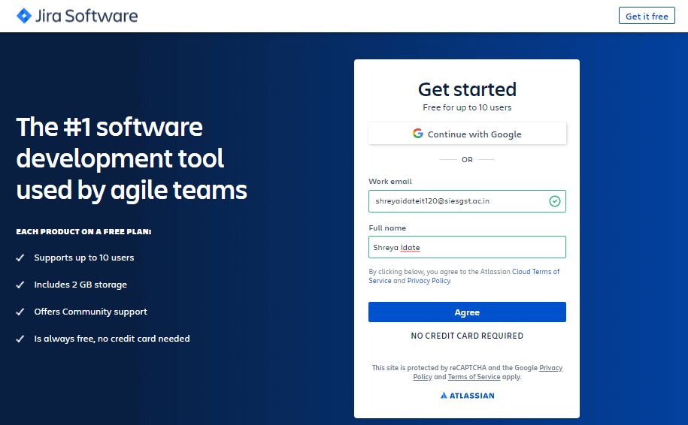

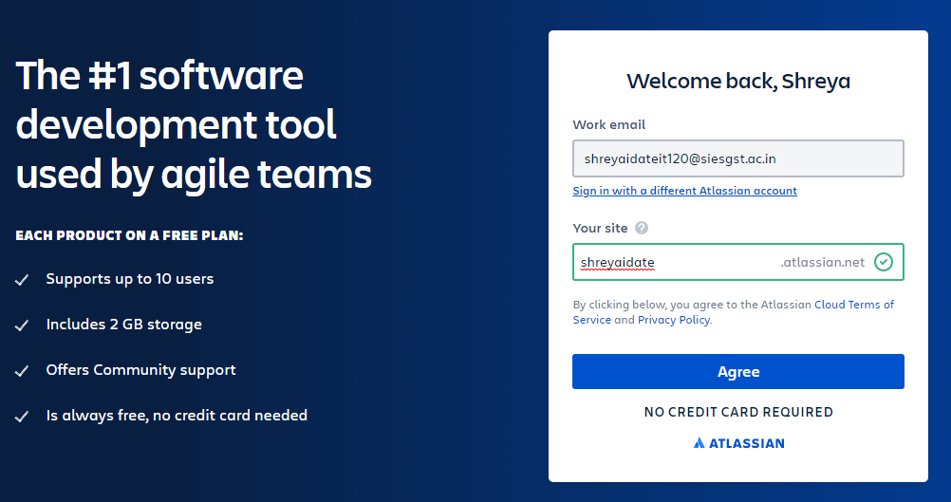

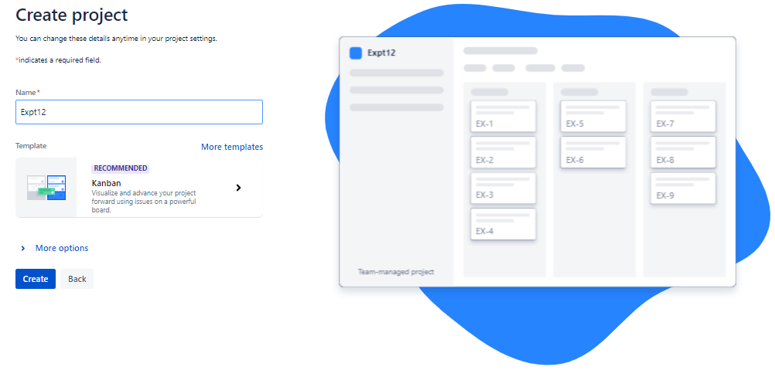

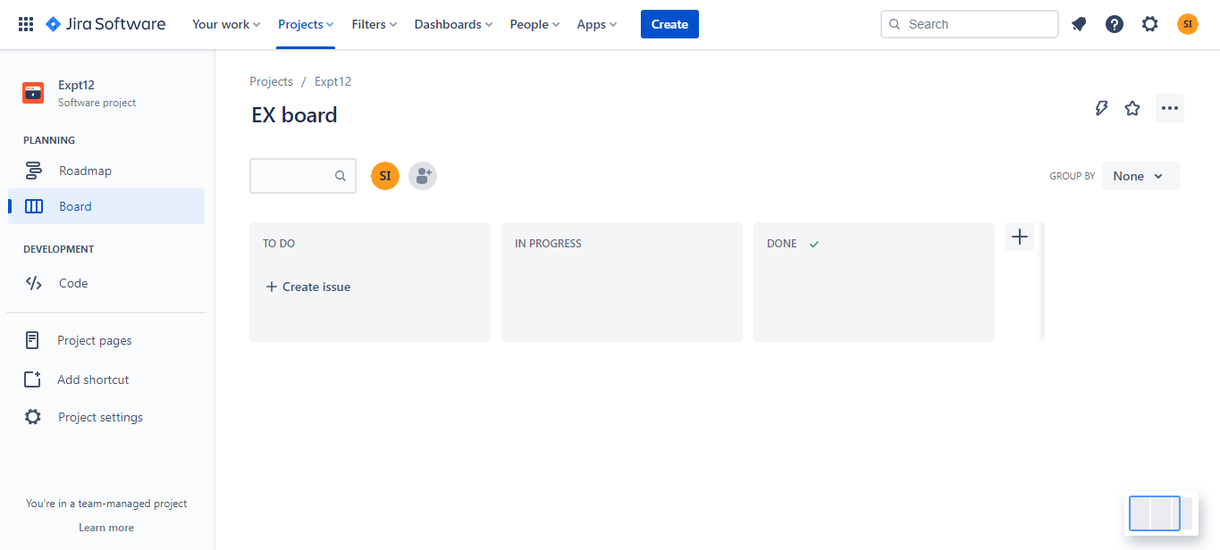

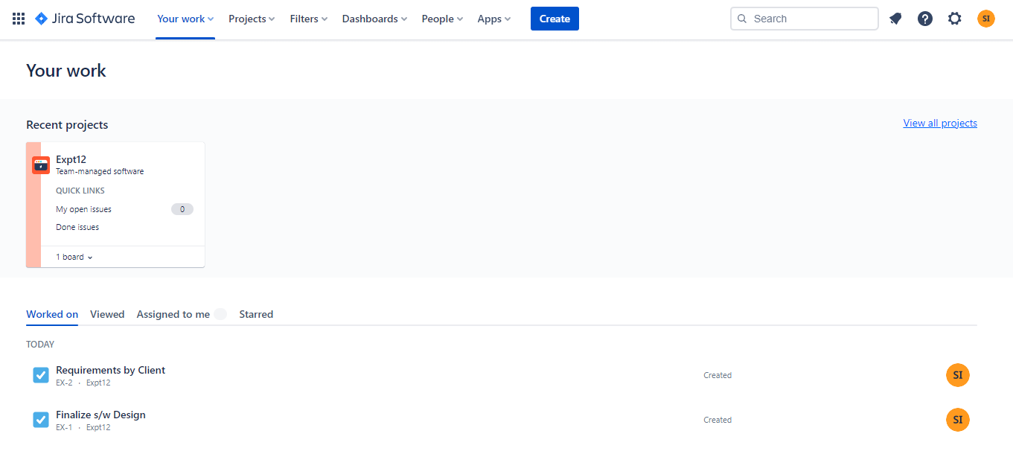

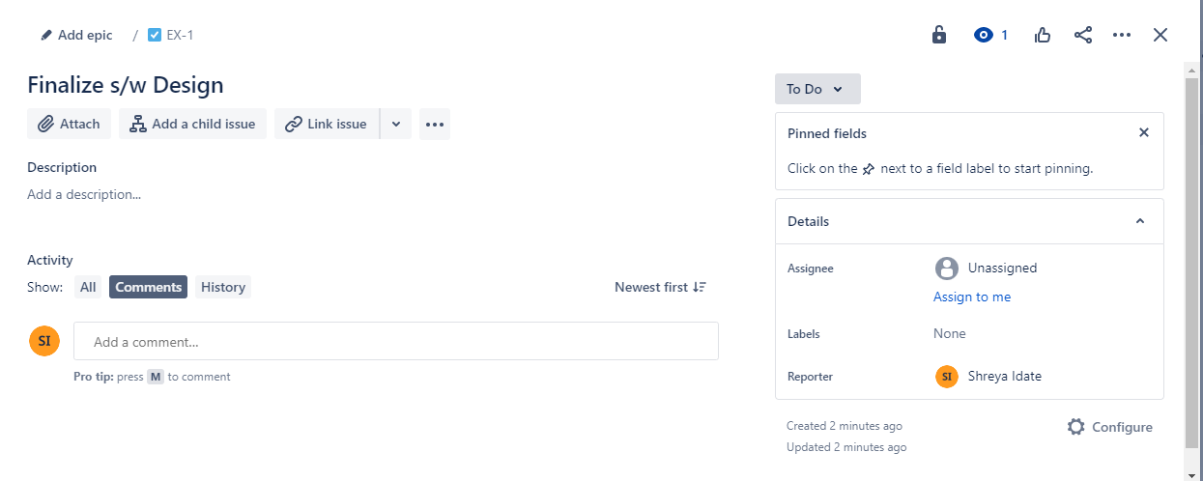

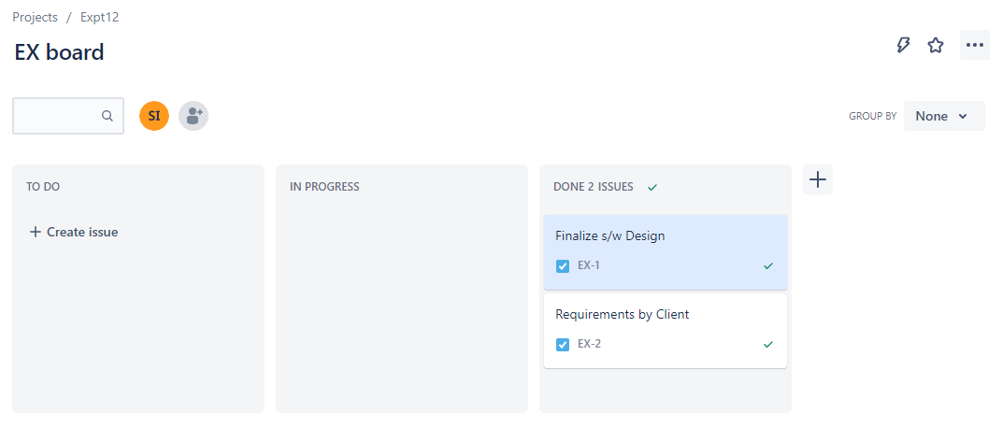

**CONCLUSION:** We were successfully able to demonstrate Jira for Agile workflow.